PRESS RELEASE | 12 April 2012
MJ Hibbett's Theory Of A Dinosaur Planet Could Be True, Says Professor

A report in this month's Journal of the American Chemical Society suggests that the terrifying Space Dinosaurs from MJ Hibbett & The Validators' album 'Dinosaur Planet' could very easily be real.
In the paper 'Evidence for the Likely Origin of Homochirality in Amino Acids, Sugars, and Nucleosides on Prebiotic Earth' Professor Ronald Breslow theorises that Tyrannosaurus Rex and other dinosaurs may have evolved on other planets to become more intelligent than humans.
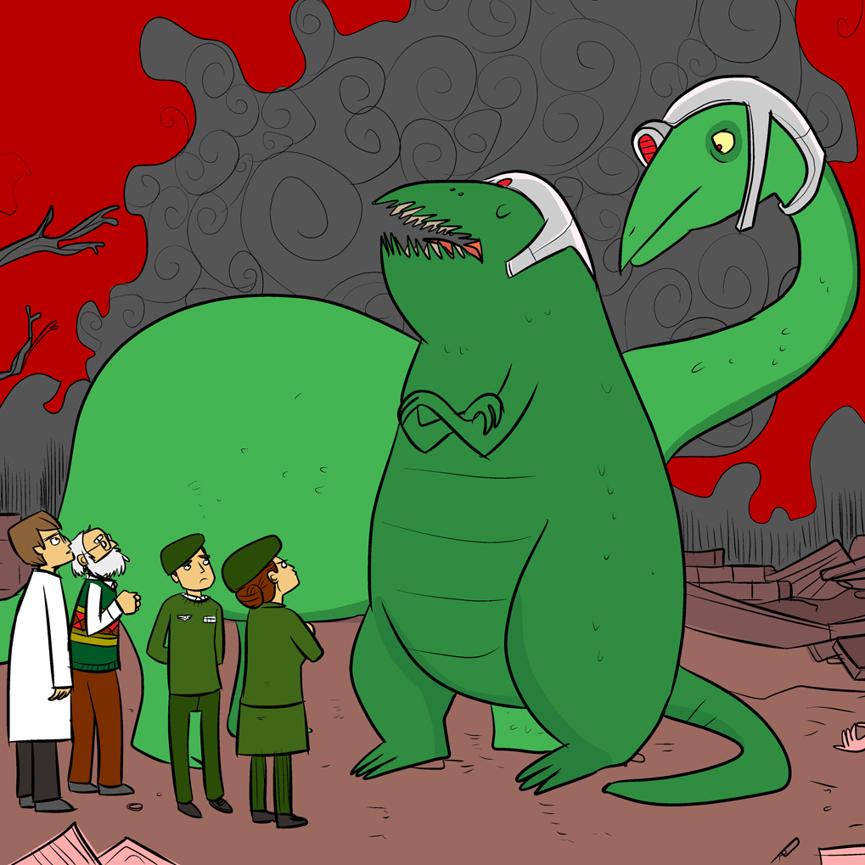
(Space Dinosaurs: artist's impression by John Allison)
Professor Breslow, of Columbia University, says: "Elsewhere in the universe there could be life forms (which) could well be advanced versions of dinosaurs, if mammals did not have the good fortune to have the dinosaurs wiped out by an asteroidal collision, as on Earth. We would be better off not meeting them."
Alarmingly this is almost exactly what does happen at the start of the rock opera 'Dinosaur Planet'. Space Dinosaurs (whose ancestors escaped the Cretaceous-Tertiary Extinction event 65 million years ago) return to Earth as "kill-crazed psychopathic fans of war and death" armed with high tech weapons of destruction, intent on wiping out humanity.
"I did do some research into the science of dinosaur extinction while writing the album and came up with some ideas about what could have happened to them", says lead singer MJ Hibbett, "I never expected to be proved right!"
The album, which has also been quoted in the magazine of the Smithsonian Institute, goes on to posit the theory that the Dinosaurs were kidnapped by Giant Robots who will follow their prey to Earth and destroy the planet. "I'd be quite happy to be wrong about that," says MJ.
continues overleaf...
Background
The abstract for Professor Breslow's paper can be found at http://pubs.acs.org/doi/abs/10.1021/ja3012897
Most of the theory behind Space Dinosaurs is explained in the song 'The Theory Of A Dinosaur Planet', as follows:
The Cretaceous-Tertiary Extinction event occurred, as far as we know,
Sixty five point five million years ago
But even the interval of error in that estimated date
Is longer than it took us humans to evolve from apes
And if in that time we mammals managed to conquer space
I believe the Dinosaurs could have done the same
That's The Theory Of A Dinosaur Planet - the dinosaurs packed up and got away

They must have had astronomers who saw the meteorite
And they must have hypothesised the planet's dreadful plight
I expect their engineers would have come up with the plan
That said "Let's build a bunch of spaceships and get out while we still can"
And in sixty five million years they will undoubtedly have changed
Into a peaceful, deeply philanthropic kind of race
That's The Theory Of A Dinosaur Planet - there are dinosaur philosophers in space

But now that they are here I must say that I'm surprised
To find that they are frankly not very nice
I thought that they would bring a wealth of hope and peace and love
But all they've bought is lots and lots of tanks and knives and guns
And if they're all kill-crazed psychopathic fans of war and death
It could mean the end of human life and worse still even yet
That my theory of A Dinosaur Planet is not entirely correct

The album further promotes good scientific method through the songs 'A Little Bit' (about the benefits of collaboration) and 'Literature Search'. Both songs have videos online.
'Dinosaur Planet' started off as an Edinburgh Fringe show. MJ Hibbett was inspired to write it after seeing a slightly disappointing one-man version of Jeff Wayne's 'War Of The Worlds'.
Guest stars include Phil Wilson (The June Brides), Chris T-T, Keith Top Of The Pops, BBC One continuity announcer Claire Gibb and BBC Radio Tees DJ Bob Fischer.
MJ Hibbett & The Validators have performed live on Radio One, had a Record Of The Year in Rolling Stone, an Album Of The Day on 6Music, toured all around the world and very narrowly avoided writing an autobiography. They're probably best known for 'Hey Hey 16K', the world's first ever internet viral hit.
All of the album illustrations were drawn by John Allison, creator of the long running online comics Bad Machinery, Bobbins and Scarygoround.
www.dinosaurplanet.co.uk

