PRESS RELEASE | 14 October 2012

Band Target Children With Free Space Dinosaurs

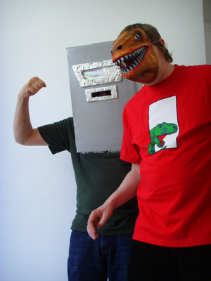
Indie legends MJ Hibbett & The Validators have turned their science fiction rock opera 'Dinosaur Planet' into a stage musical and are offering free performance rights to schools, youth groups and amateur dramatic societies.

'Dinosaur Planet' was released as a full-cast special effects- laden concept album earlier this year to great acclaim from the science fiction community. SFX Magazine called it "Jeff Wayne's new competition", io9.com said it was "the space dinosaurs vs. giant robots rock opera you've been waiting for", and Den Of Geek called it "a ridiculous, charming, delightful oddity".

Now the band would like to see it performed by amateur groups. "I've always thought it would make a brilliant school play, " says MJ Hibbett. "The songs are very easy to play and sing along to, and making the giant robots and space dinosaurs would be a lot of fun! It also contains a lot of educational information, such as the need for good academic research methods, and ways not to get eaten by space dinosaurs."

This new adaptation of the story is based on the two-man musical which MJ and his friend Steve Hewitt have been touring around the country for the past two years. The pair performed this version at the Edinburgh Fringe, Camden Fringe, Green Man and Leicester Comedy Festivals.

The show is available for amateur groups to perform throughout 2013. Anyone who applies will also receive a songbook, videos, artwork, free downloads and even a visit by MJ Hibbett himself. Those interested can find out more at the show's website and can email info@dinosaurplanet.co.uk for a copy of the script.

For more information contact MJ Hibbett at info@dinosaurplanet.co.uk
http://www.dinosaurplanet.co.uk/schools
Background
MJ Hibbett & The Validators have performed live on Radio One, had a Record Of The Year in Rolling Stone, an Album Of The Day on 6Music, toured all around the world and very narrowly avoided writing an autobiography. They're probably best known for 'Hey Hey 16K', the world's first ever internet viral hit.
Guest stars on the 'Dinosaur Planet' concept album include Phil Wilson (The June Brides), Chris T-T, Keith Top Of The Pops, BBC One continuity announcer Claire Gibb and BBC Radio Tees DJ Bob Fischer. All of the illustrations were drawn by John Allison, creator of the long-running online comics Bad Machinery, Bobbins and Scarygoround.

FAQs for schools
How many parts are there?
There are 20 named parts in the show – seven male and five female, with the rest interchangeable – and scope for as many extras as you like.
How long it it?
The two-man version of the show generally lasted about an hour, although this was usually performed at quite a pelt. We estimate that the full-cast version will take about 70 minutes, or longer if you're having fun with the battle scenes.
Is it suitable for children?
Yes. The live adaptation features no swearing and only the mildest of peril.
Does it have any educational value?
Very much so. The core message of the play is that the world can only be saved by teamwork and good academic research methods. It also encourages the questioning of accepted ideas and contains an awful lot of information about iridium.
Why is it free?
We're offering the play to amateur productions in 2013 for three reasons – firstly, because we'd like more people to find out about the show, secondly to get feedback about how it works as a play, and finally so that we can demonstrate to theatrical publishers that it has been successfully performed, in the hope that they will take it onto their books for future performances.
Dinosaurs and Giant Robots? How can we make those?
There are many ways to represent the more unusual characters on stage. In the two-man touring show we wore Dinosaur masks and cardboard heads but you could use figures held up on sticks, groups of children acting together, silhouettes or even puppets. Part of the reason for offering the show to groups for free is to see what people will come up with!
Does it need a big band?
It's entirely up to you. The original two-man show was performed with a single guitar, whilst the concept album has a huge array of instruments including a choir and half an orchestra! All of the songs are very easy to play with basic guitar chords – to see for yourself download a copy of the songbook, Let's All Play The Dinosaur Way.

