PRESS RELEASE
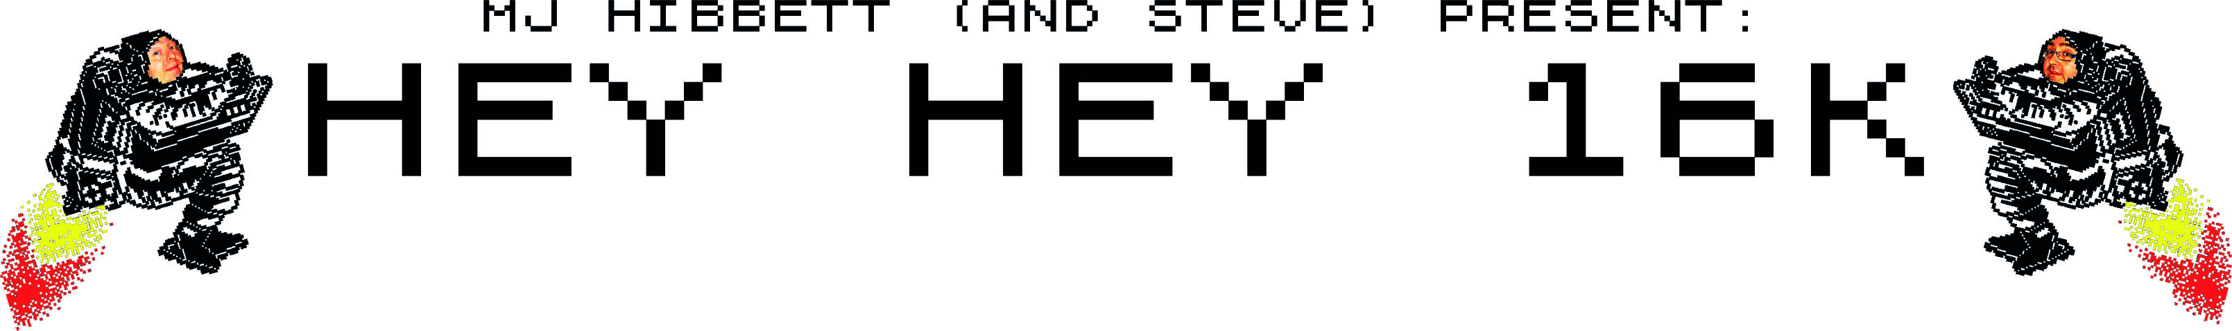

A Piece Of Internet History

'Hey Hey 16K' is a brand new two-man comedy musical based on a piece of internet history.

In 1999 International Rock Star MJ Hibbett had the bright idea of releasing his hymn to the ZX Spectrum, 'Hey Hey 16K', as the world's first ever internet single. It was a firm favourite among computer geeks and indie fans, but it wasn't until 2004 that it became a worldwide smash. Rob Manuel of b3ta.com created an animation for the song, turning it into one of the first ever viral videos, and it was downloaded over two million times in its first fortnight.

Now MJ has used the song as the basis for a musical starring himself and his friend Steve Hewitt. Steve's very excited about it. "If just 0.0025% of the people who've seen the video come to the show each night, we'll sell out!" he says.

This is the fourth musical that the duo have performed. In previous years they've thrilled audiences with the science fiction extravaganzas 'Dinosaur Planet', 'Moon Horse VS The Mars Men Of Jupiter' and 'Total Hero Team', but this year's show is a bit more personal.

"MJ goes back in time to the 1980s to meet a teenaged version of himself, played by me," says Steve. "It’s the role of lifetime, though I did have to shave my beard off to do it!"

As well as home computers, time travel and teenage memories, the show features advice on beer, a biography of Ada Lovelace, brand new songs, tap dancing, Dad jokes, and even a bit of hula hooping. All this and a free badge too!

Contact MJ Hibbett on 07787 560908 or mjhibbett@gmail.com
for pictures, sound files, or to arrange interviews.
www.heyhey16k.com

