PRESS RELEASE | 23 September 2013

New Single From MJ Hibbett & The Validators

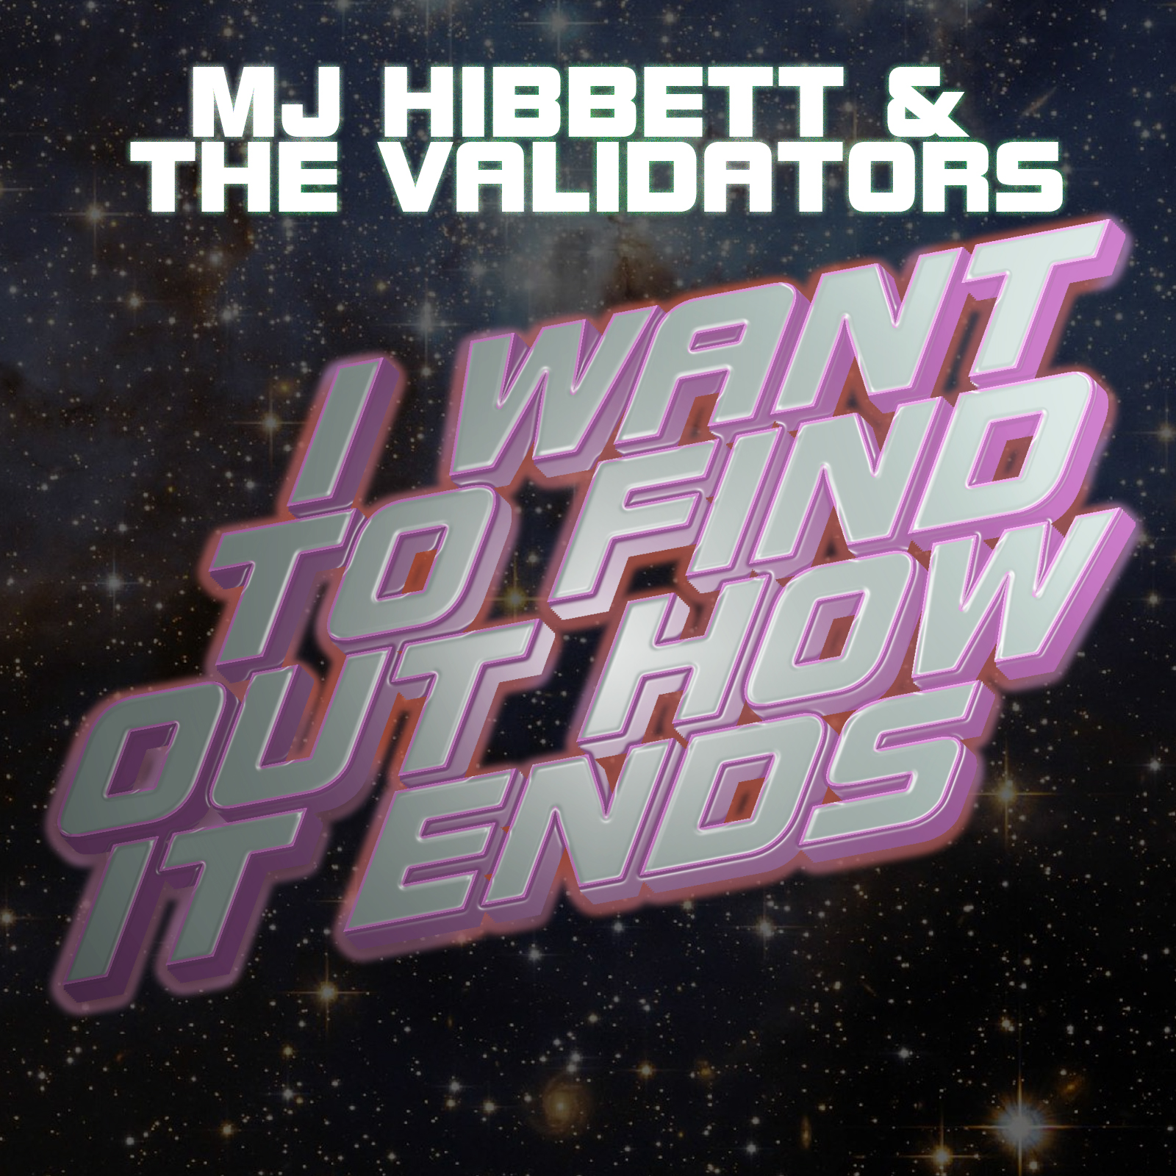

'I Want To Find Out How It Ends' is the new single from MJ Hibbett & The Validators, available to buy today. It's the theme tune to an online sitcom, and comes with a video featuring younger versions of the band members in a time travel adventure.

MJ Hibbett was approached to write the song last year by Seb Patrick and James Hunt, creators of the new sitcom 'A Brief History Of Time Travel'. The band recorded the theme tune as well as incidental music for the six part series, which also begins today.

The video for the single was filmed by Tim and Emma Pattison (Validators drummer and backing singer respectively) in their home village of Woodhouse Eaves in Leicestershire. It features their daughters Edie and Lola, along with school friends, portraying younger versions of MJ Hibbett & The Validators. The time travel video is an affectionate homage to 1970s children's TV films.

- - -

MJ Hibbett & The Validators have performed live on Radio One, had a Record Of The Year in Rolling Stone, an Album Of The Day on 6Music, toured all around the world and very narrowly avoided writing an autobiography. They're probably best known for 'Hey Hey 16K', the world's first ever internet viral hit.

For more information see http://www.mjhibbett.com/iwanttofindouthowitends
or contact MJ Hibbett at mjhibbett@gmail.com

